# **Pre-Requirements**

Installation of Wing Personal Application on your computer.

* + Note: If you have issues with installing Wing Personal App, you can use an online Python compiler such as: <https://www.onlinegdb.com/online_python_compiler>
  + If you use an online editor, make sure to sign up for the editor so that you can save your Python files.

# **Requirements**

Just follow the steps. If you use an online editor, try to do the same thing on your online editor.

# **Problem1**

Submit your first assignment. This is a test assignment to make sure you know where to find the assignments and how to upload your work. Please find the assignment link below.

For this assignment, you need to the following steps:

1. Open the Wing Personal application you have already installed in Activity 3. (Go to next page for step2)

2. Create a new file (look at the image how to do it)

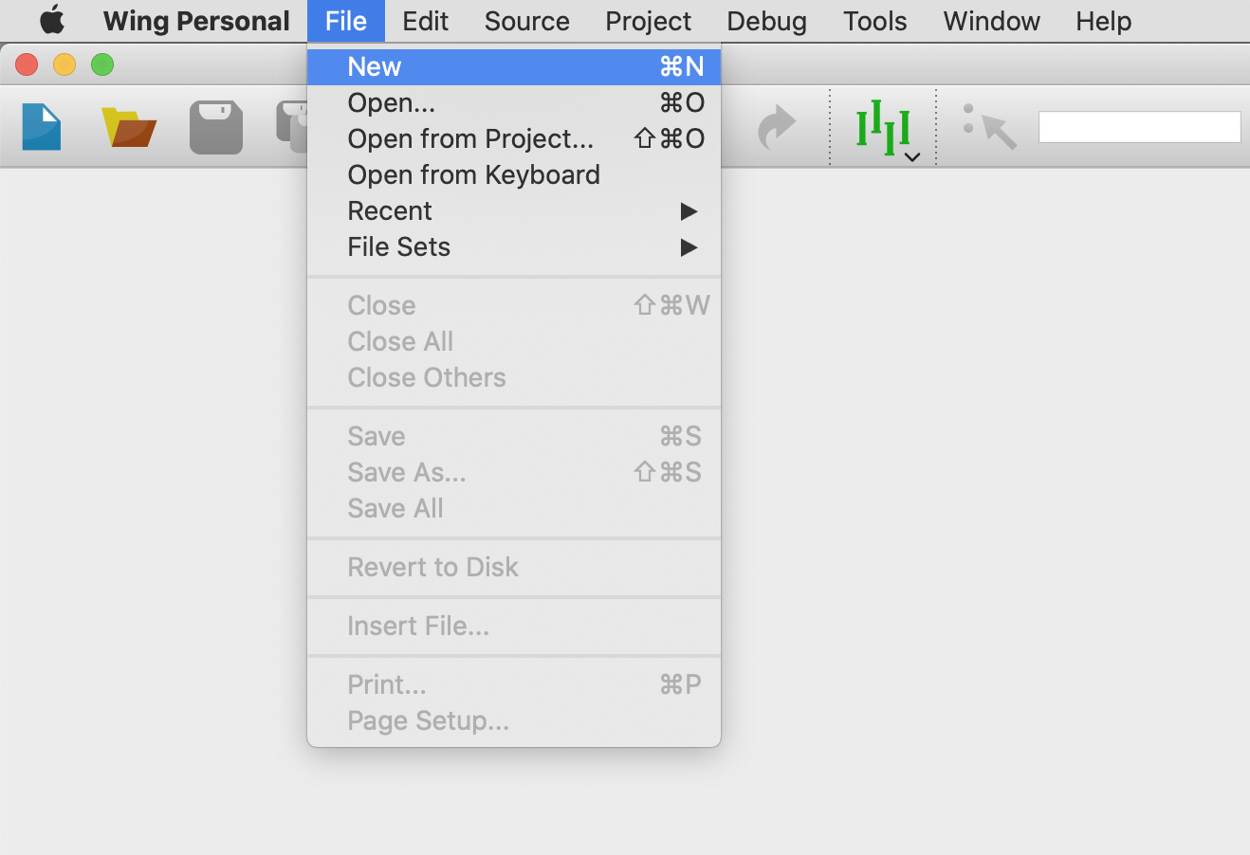

# 3. Now you have created a new Python file. As you can see the name of your file is something like [filename].py for instance untitled-1.py. Now you need to write the following line in the new file. Please make sure to write exactly what you see in the following image. If you have any issue make sure there is no extra space or line and all the words are written as you see in the image.

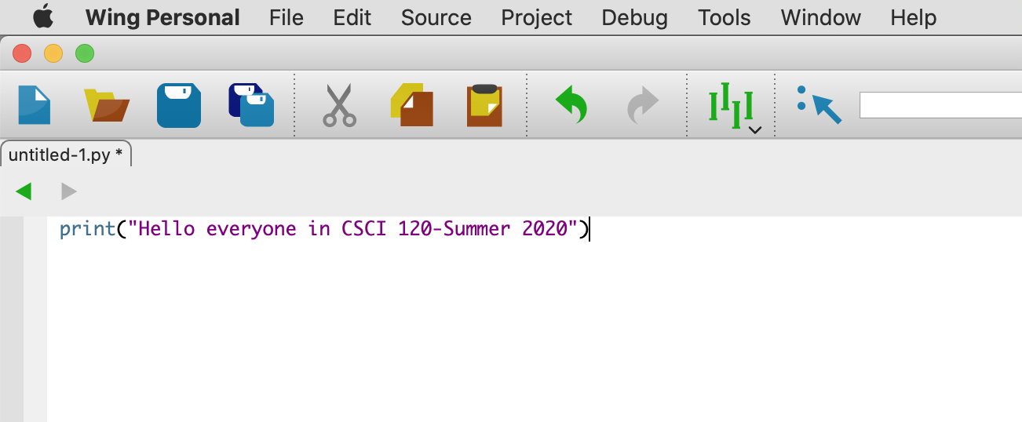

4. Now you need to save your first Python program. Look at the image below:

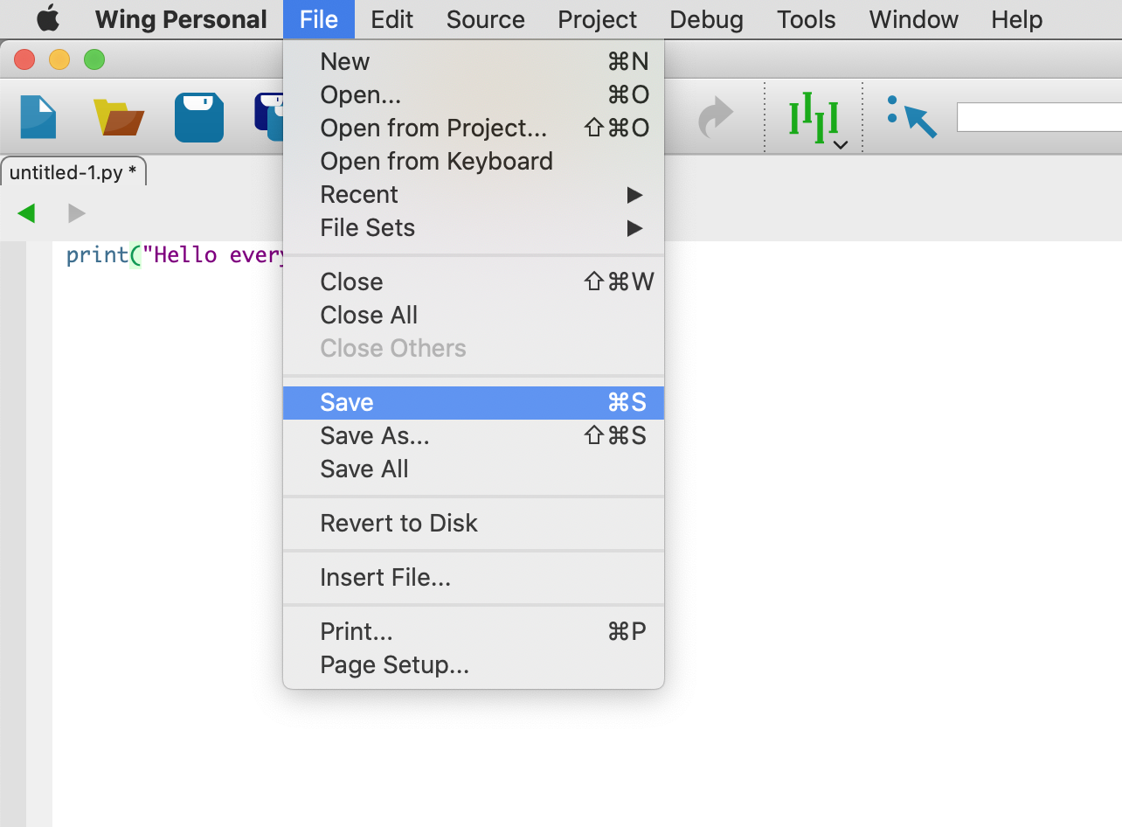

5. Now you can run your first Python program :)

Note: You may be asked again to save your file if any change has been made since the last time you have saved your file. If you are prompted to save your file please press OK and save it.

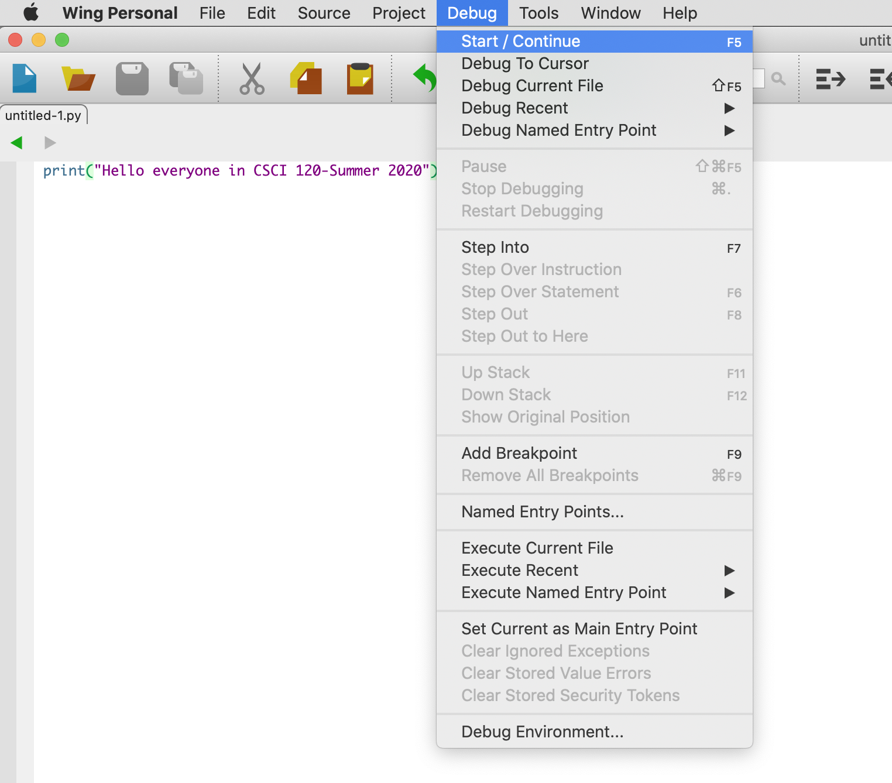

6. See the result of running your first program.

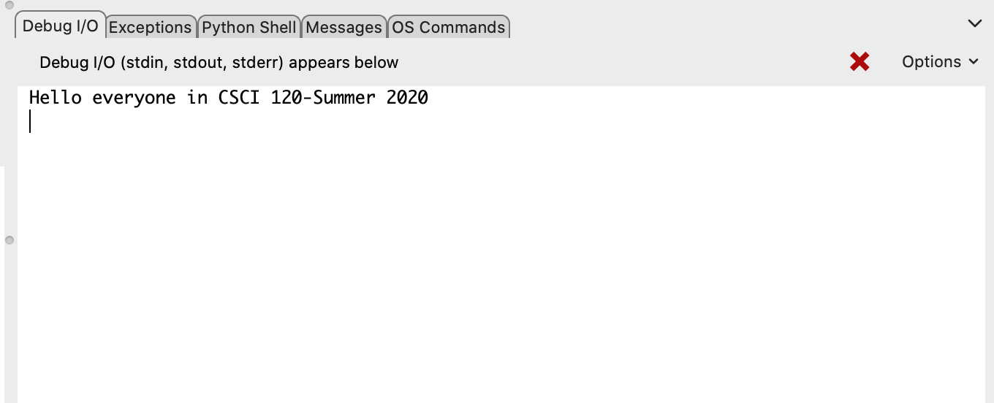

Great! You have finished your first assignment. Well done. Now please upload this python file on Moodle. You should see a section under this assignment to upload your file.